Computer Hardware Identification

**Date:**

**Group Name:**

**Group Members (2 Max):**

In this activity, in groups of 2, you will be taking a computer apart. Using a working computer and a phone, take pictures of the components and enter a description of the component and what it does. If the computer that is being dissected does not have the component, then getting an image from the internet is acceptable. Identify and describe the following computer components:

1. Case
   * Image: A black rectangular object on a wooden surface

     Description automatically generated with medium confidence
   * Description: The outer shell of a computer
   * Function: safeguards of a pc or other computer guards
2. Motherboard
   * Image: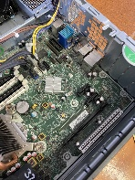
   * Description: the backbone that ties the computer's components together at one spot and allows them to talk to each other.
   * Function: serves as a single platform to connect all of the parts of a computer together.
3. CPU
   * Image: 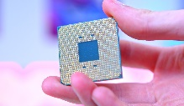
   * Description: The component of a computer system that controls the interpretation and execution of instructions.
   * Function: guides the computer through the various steps of solving a problem.
4. GPU
   * Image: A picture containing electronics, text, electronic device, electronic engineering

     Description automatically generated
   * Description: a specialized processor originally designed to accelerate graphics rendering.
   * Function: accelerate graphics rendering.
5. RAM
   * Image: 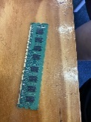
   * Description: random-access memory.
   * Function:  a temporary memory bank where your computer stores data it needs to retrieve quickly.
6. Storage Device
   * SSD vs HDD
7. Cooling
   * CPU
     1. Image: 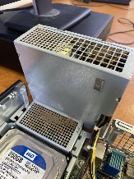
     2. Description: removal of heat, usually resulting in a lower temperature and/or phase change.
     3. Function: a function of temperature indicating the rate that a gas cools,
8. PSU (Power Supply Unit)
   * Image: 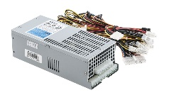
   * Description: a hardware device that converts AC electricity into DC electricity and then distributes it to the rest of the computer.
   * Function:  converts mains AC to low-voltage regulated DC power for the internal components of a computer
9. Monitor
   * Image: A computer monitor with a colorful screen

     Description automatically generated with low confidence
   * Description: an electronic output device which displays images in pictorial form on the screen.
   * Function: displays information in pictorial or textual form
10. Mouse
    * Image: A black computer mouse

      Description automatically generated with medium confidence
    * Description: a small device that a computer user pushes across a desk surface in order to point to a place on a display screen and to select one or more actions to take from that position
    * Function: controls the motion of a pointer in two dimensions in a graphical user interface (GUI).
11. Keyboard
    * Image: A picture containing text, computer, keyboard, electronics

      Description automatically generated
    * Description: for putting information including letters, words and numbers into your computer.
    * Function: act as an input device.